Unit 3 – Chemical Bonding

# http://wps.prenhall.com/wps/media/objects/3311/3391094/imag0901/AAAVJIR2.JPG Learning Objectives

# Progress Tracker

## Test Date:

Webassign Due Score





Packet Progress Checks

## Test Readiness Checks:

* My webassign scores indicate I am ready for the test.
* I went to ASP for Webassign help when needed.
* I have completed the unit review AND checked my answers.
* I am aware that I cannot retake the test unless my webaassign and packet progress checks are all above 80%.

3.1 Chemical Bonding and Naming

3.2 Lewis Structures

3.3 VSEPR Theory

**3.1 Chemical Bonding and Naming**

* Write the **formula** for **ionic compounds** based on the charge of the **cations** and **anions** involved. Be able to do this with:
  + Simple monatomic ions
  + **Polyatomic ions**
* Write the formula for ionic compounds given the **name** of the substance. Be able to do this with:
  + Simple monatomic ions
  + Polyatomic ions
  + Transition metal containing ions
  + Other multivalent ions such as Pb and Sn
* Write the name of ionic compounds given the formula. Be able to do this with:
  + Simple ionic compounds (given a simple periodic table.)
  + Polyatomic containing compounds (given an ion chart)
  + **Roman numeral** containing compounds
* Convert names to formulas (and vice versa) **for covalent compounds**:
  + Use appropriate **prefixes** (know them up to deca)
  + Determine when to use mono (and when not to)
* Distinguish between the physical properties of ionic compounds and covalent compounds and use the terms “**salt**” and “**molecule**” appropriately.
* Draw and describe a model of ionic bonding and distinguish it from covalent bonding.
* Write the name of a **hydrated** compound.
* Describe the “sea of electrons” model of **metallic bonding** and relate it to metallic properties.

# 

**3.2 Lewis Structures**

* Determine the number of **valence electrons** in a molecules.
* Draw **Lewis structures** for simple molecules, including those with extended octets (more than 8e on the central atom) and those that are electron deficient (boron and hydrogen)
* Identify the number of bonding and non-bonding pairs (lone pairs) of electrons in a completed Lewis structure.

**3.2 VSEPR Theory and Polarity**

* Explain how electron **repulsion** affects molecular structure.
* Identify the most likely shape of a molecule:
  + **linear**
  + **trigonal planar** (know the sub-shapes)
  + **tetrahedral** (know the sub-shapes)
  + **trigonal bipyramidyl** (know the sub-shapes)
  + **octahedral** (know the sub-shapes)
* Determine the **bond angles** of the molecule and make a more geometrically realistic drawing of what it would look like.
* Order elements in terms of **electronegativity**.
* Identify a bond as polar or non-polar and be able to draw a dipole arrow appropriately.
* Determine if a bond is more polar than another bond. (**polar covalent**)
* Determine if the molecule is **polar** or **non-polar** based on the shape and the electronegativity of the atoms involved in the molecule.
* Be able to explain why the molecule is polar or non-polar using your drawing.
* Give examples of how molecule polarity affects everyday life.

Understanding Chemical Formulas

Take a minute and look at BOTH the *chemical formulas* AND the *drawings*. Then turn the page and answer the questions to explore your understanding.

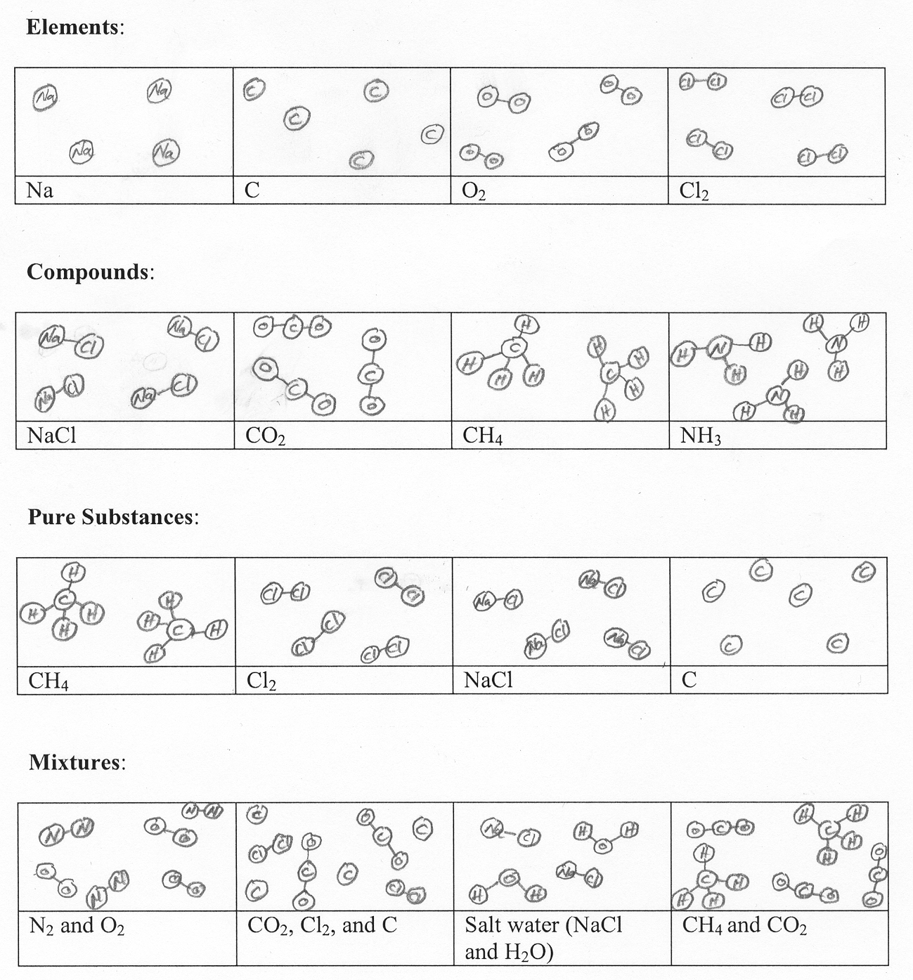

# Critical Thinking Questions

1. In the formula CH4, what does the “4” tell you about the molecule? (Use a complete sentence please!)
2. Based on the examples you see on the previous page, draw what you think the molecule SO3 would look like:
3. Why is this NOT an SO3 molecule? Explain.

S

O

O

O

For the statements in 4 and 5, state whether you agree or disagree. If you disagree, then explain why and give an example.

1. **Elements** must contain individual atoms that are not bonded together.
2. **Pure substances** can only be elements. (They cannot contain compounds)
3. In your own words, what is the difference between an **element** and a **compound**?

1. In your own words, explain the requirement for a substance to be “pure”.Elements versus compounds

|  |  |  |  |
| --- | --- | --- | --- |
| **Example** | **How many elements?** | **How many compounds** | Is it pure?(Y/N) |
| Picture #1 |  |  |  |
| Picture #2 |  |  |  |
| Picture #3 |  |  |  |
| Picture #4 |  |  |  |
| Picture #5 |  |  |  |
| Picture #6 |  |  |  |
| Picture #7 |  |  |  |
| Picture #8 |  |  |  |
| Picture #9 |  |  |  |

1. How many atoms of each type are in these formulas?
   1. NaCl Na = Cl =
   2. Na2O Na = O =
   3. NaHCO3 Na = H = C = O =
   4. K2CO3 K = C = O =
   5. Ca(NO3)2 Ca = N = O =
   6. Mg(HCO3)2 Mg = H = O = C =

Make an “Atom Counting List” for these compounds

11. (NH4)2S 12. Ni3(PO4)2

13. Cr(OH)3 14. Ba(ClO3)2

15. Mn3N4 16. Cu(CO3)2

17. Ca(NO3)2 18. Al2(HPO4)3

19. MgSO4 20. Ca3(PO4)2

21. B2(SO3)3 22. Co2S

Writing Formulas of Ionic Compounds

For each of the following, write the correct formula. SHOW YOUR WORK with an ion counting list.

|  |  |  |  |  |  |
| --- | --- | --- | --- | --- | --- |
| Problem | Cation | Anion | Work area! | Formula | Name (Leave this blank  for now.) |
| Example | Na+1 | S-2 |  |  |  |
| 1 | B+3 | F-1 |  |  |  |
| 2 | Ag+1 | N-3 |  |  |  |
| 3 | Cu+2 | O-2 |  |  |  |
| 4 | K+1 | Cl-1 |  |  |  |
| 5 | Fe+3 | S-2 |  |  |  |
| Problem | Cation | Anion | Work area! | Formula | Name (Leave this blank  for now.) |
| 6 | Zn+2 | C-4 |  |  |  |
| 7 | Li+1 | Se-2 |  |  |  |
| 8 | Ca+2 | N-3 |  |  |  |
| 9 | Cs+1 | P-3 |  |  |  |
| 10 | Mg+2 | F-2 |  |  |  |
| 11 | Al+3 | S-2 |  |  |  |

Simple Ionic Compound Practice 

### Predict the formula of each of these compounds based on the charge of the ions involved. BE SURE TO SHOW YOUR WORK WITH ION COUNTIN LISTS. The first is done for you.

1. Cesium nitride WORK AREA

**Cs+ N-3**

**Cs+**

**Cs+**

**+3 -3**

Cs3N

1. Strontium fluoride
2. Aluminum oxide
3. Sodium selenide
4. Potassium iodide
5. Beryllium bromide
6. Aluminum nitride
7. Barium chloride

## For these last two, what mistakes were made in writing the formulas?

1. Calcium phosphide

CA3P2

1. magnesium sulfide

SMg2

Polyatomic Ion Notes 

Definition: A polyatomic ion is….

Which of these is a polyatomic ion?

Cl- SO4-2 PO3-3 O-2 Na+ MnO4-

NH4+ S-2 I- CN- OH- N-3

Most polyatomic ions are cations or anions? What is the one exception?

All ionic compounds are made up of one positive ion and one negative ion. Draw a line dividing the positive side and the negative side in each of these.

NaClO3 __________________________________________

BeSO3 __________________________________________

KMnO4 __________________________________________

Li2CO3 __________________________________________

Mg(NO3)2 __________________________________________

Sr3(PO4)2 __________________________________________

Ca(OH)2 __________________________________________

KCN __________________________________________

NH4Cl __________________________________________

Ba(NO2)2 __________________________________________

For each of the compounds above, write a name.

Polyatomic Ion Practice 

Determine the formula for each of these compounds:

|  |  |  |  |
| --- | --- | --- | --- |
| Compound | Formula and Charge of cation | Formula and Charge of anion | Compound Formula |
| Sodium carbonate |  |  |  |
| Aluminum chlorate |  |  |  |
| Calcium nitrate |  |  |  |
| Magnesium permanganate |  |  |  |
| Ammonium sulfate |  |  |  |
| Ammonium sulfide |  |  |  |
| Lithium hydroxide |  |  |  |
| Strontium cyanide |  |  |  |
| Calcium fluoride |  |  |  |

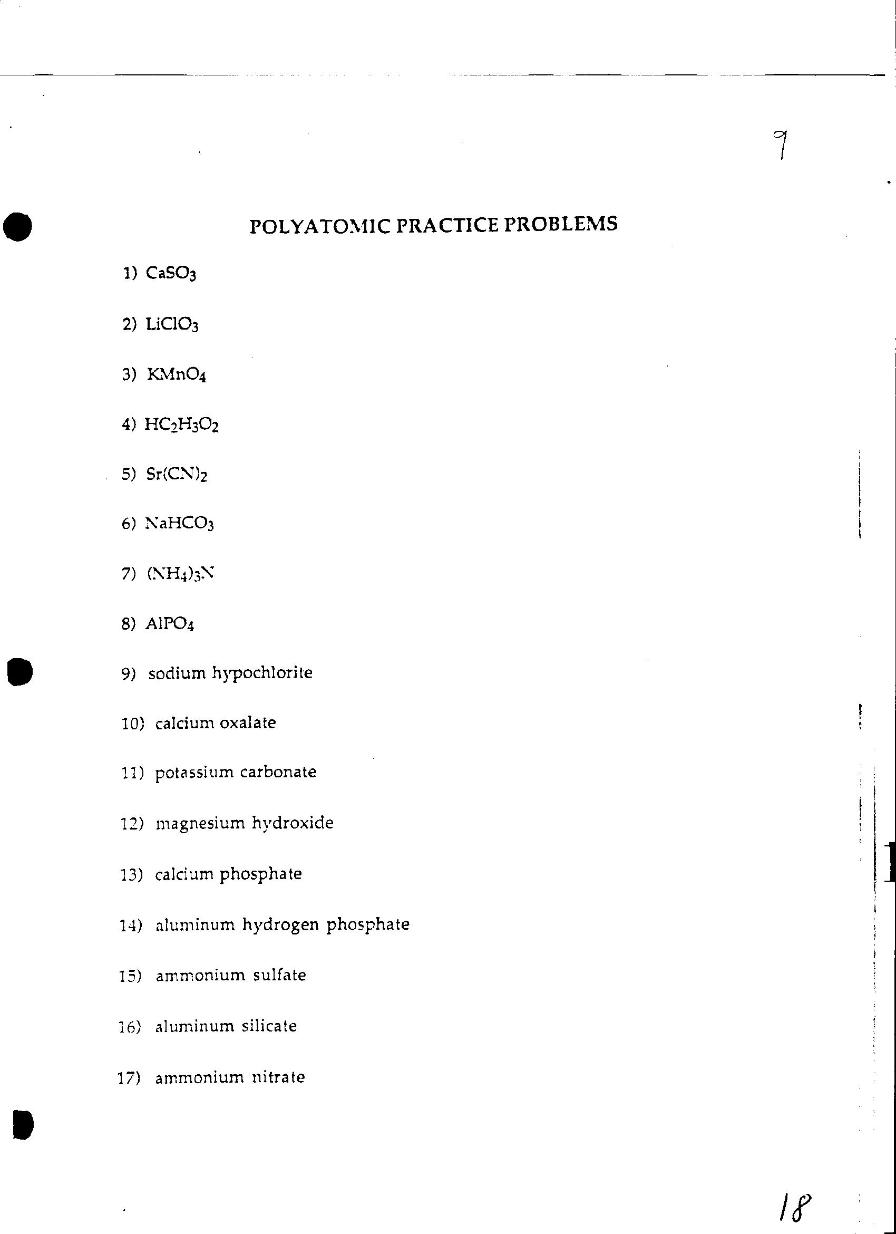

Transition Metal Notes 

Highlight the multivalent atoms on this periodic table.

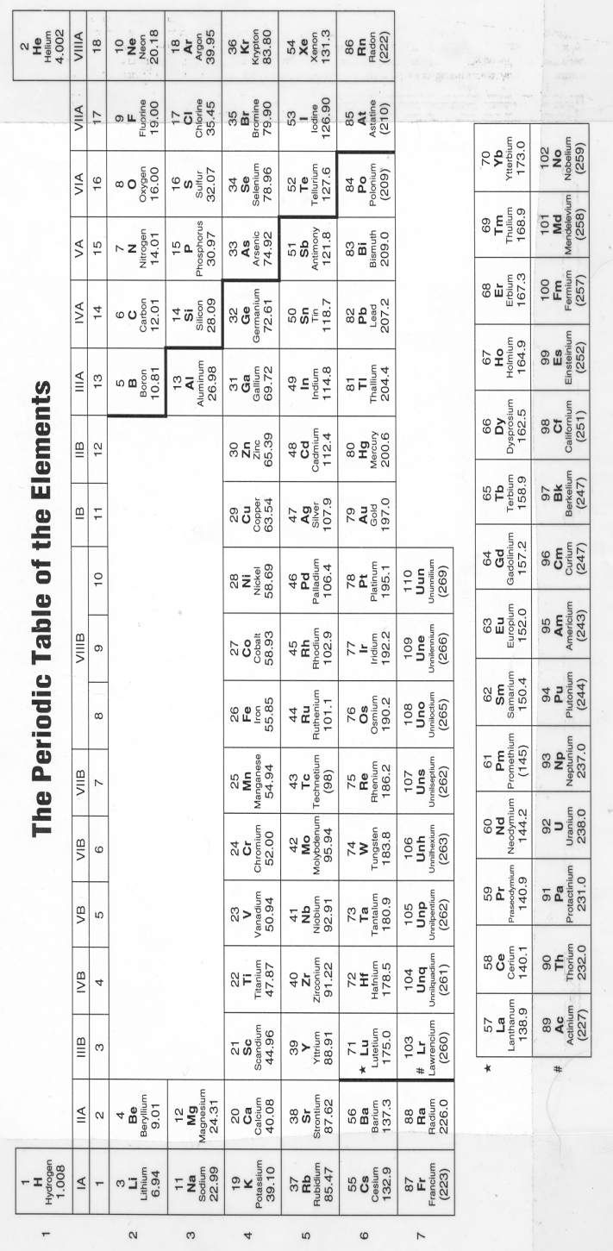

*Example: manganese (IV) chloride*

Transition metal compounds contain a roman numeral. The roman numeral tells you the _____________________ of the compound.

+1 = +4 =

+2 = +5 =

+3 =

Why do we use a roman numeral for transition metal compounds, but not others? ____________________________________________________________________________________________________________________________________________________________________________________________________________________________________________________________________________________

# Formulas of Transition Metal Compounds

|  |  |  |  |
| --- | --- | --- | --- |
| Compound | Cation | Anion | Formula |
| Copper (I) sulfide |  |  |  |
| Iron (III) cyanide |  |  |  |
| Nickel (II) sulfate |  |  |  |
| Cobalt (III) oxide |  |  |  |
| Chromium (II) nitrate |  |  |  |
| Titanium (IV) Bromide |  |  |  |
| Scandium (II) nitrite |  |  |  |
| Cadmium (III) acetate |  |  |  |
| Lead (IV) Iodide |  |  |  |
| Vanadium (V) hydroxide |  |  |  |
| Niobium (II) phosphate |  |  |  |

# Naming Transition Metal Compounds

Write a name for each of these compounds. Show your work.

Keep an eye out for the three compounds that do not need a roman numeral!!!!

|  |  |  |  |
| --- | --- | --- | --- |
| Problem | Formula | Work area! | Name |
| Example | Cu2S |  |  |
| 1 | Fe(NO3)3 |  |  |
| 2 | ZnBr2 |  |  |
| 3 | TiO2 |  |  |
| 4 | MgSO4 |  |  |
| 5 | Ni(OH)3 |  |  |
| Problem | Formula | Work area! | Name |
| 6 | V(C2H3O2)2 |  |  |
| 7 | Co3N2 |  |  |
| 8 | Al(CN)3 |  |  |
| 9 | ScPO4 |  |  |
| 10 | FeCl2 |  |  |
| 11 | Ag2S |  |  |

Ionic and Covalent Bond Notes 

1. Highlight the metals and the non-metals in this periodic table.

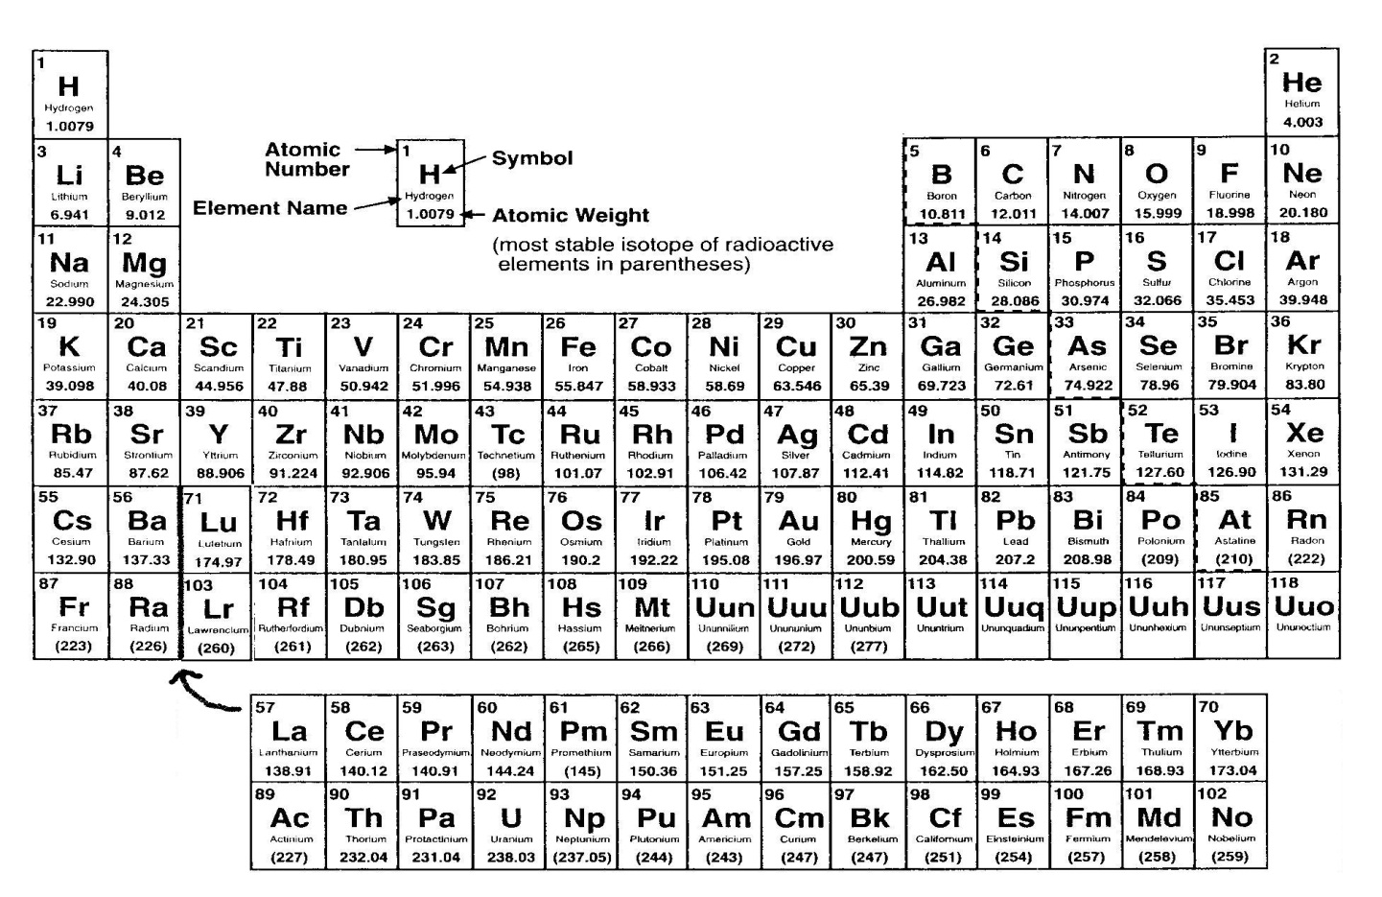

1. Ionic bonds must be between a _________________ and a _____________
2. Covalent bond are made between a ______________ and a ____________
3. Label the compound as ionic or covalent:

N2O K3N

____________ ____________

NaNO3 SO3

____________ ____________

1. Compounds that are ionic are called _______________________.
2. Compounds that are covalent are called _____________________.
3. Describe an IONIC bond and draw a model:
4. Describe a COVALENT BOND draw a model:

Ionic versus Covalent Practice 

|  |  |  |  |
| --- | --- | --- | --- |
| Compound | Is the compound Ionic or Covalent? | Is it a Molecule or Salt? | Provide a name for the IONIC COMPOUNDS ONLY |
| N2O5 |  |  |  |
| MgSO4 |  |  |  |
| NaCl |  |  |  |
| K3PO4 |  |  |  |
| H2O |  |  |  |
| NH3 |  |  |  |
| P4O10 |  |  |  |
| C2H6 |  |  |  |
| PF3 |  |  |  |
| SBr6 |  |  |  |

Naming Covalent Compounds 

Covalent compounds are named using prefixes.

|  |  |
| --- | --- |
| Number | Prefix |
| 1 | Mono |
| 4 |  |
| 2 |  |
| 8 |  |
| 5 |  |
| 6 |  |
| 7 |  |
| 8 |  |
| 9 |  |
| 10 |  |

Provide formulas for each of the following compounds.

|  |  |
| --- | --- |
| Name | Formula |
| Nitrogen trihydride |  |
| Diphosphorus pentoxide |  |
| Hydrogen monoiodide |  |
| Bromine pentafluoride |  |
| Carbon dioxide |  |
| Iodine tetrafluoride |  |
| Dihydrogen monoxide |  |

Covalent Compound Naming 

Provide names for each of the following compounds.

|  |  |
| --- | --- |
| Formula | Name |
| ClF3 |  |
| NO2 |  |
| BF3 |  |
| C4H8 |  |
| PCl5 |  |
| CO |  |
| Cl2O7 |  |

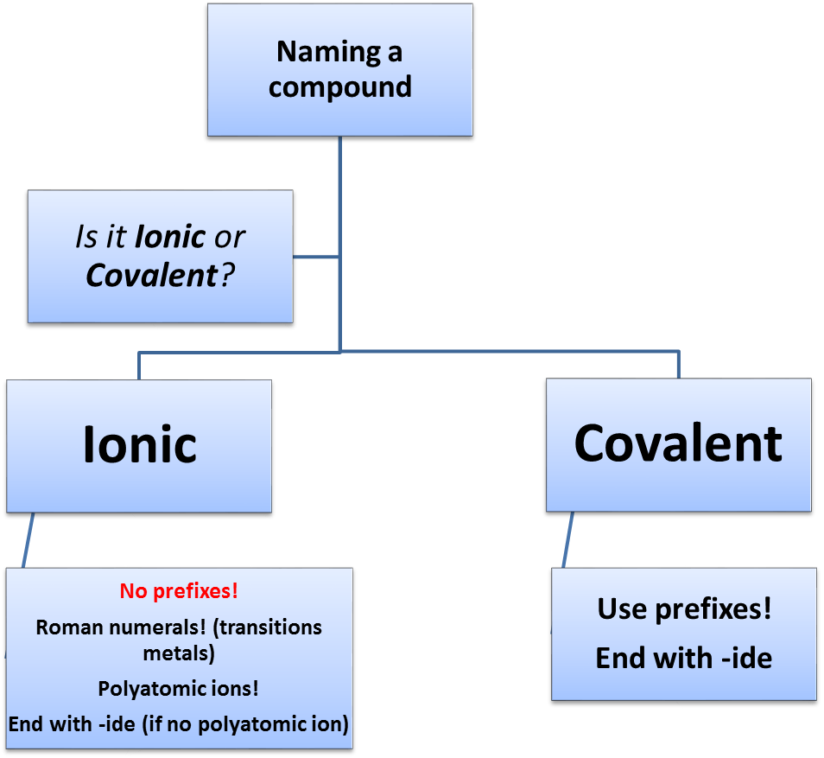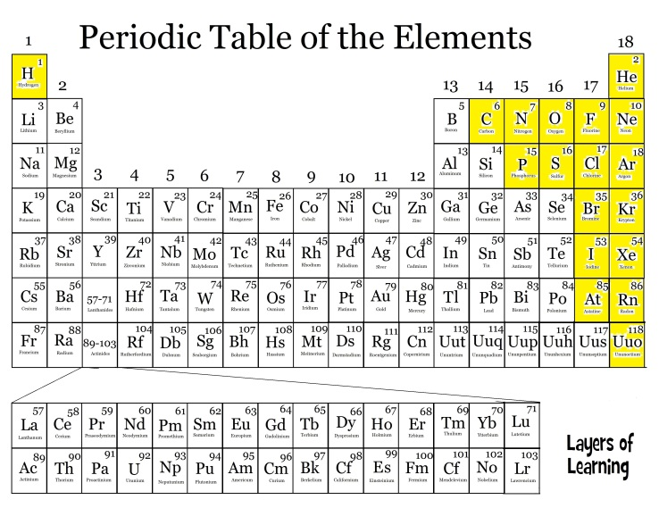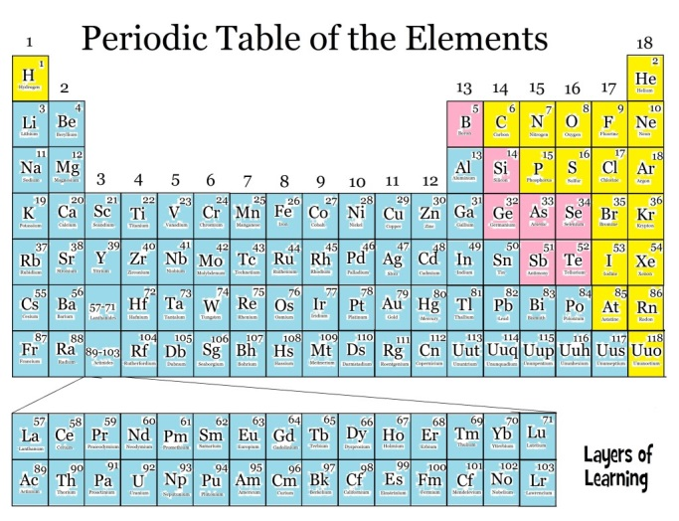

One of each!!!

Both Non-metals!

Naming and Formula Writing Challenge! 

1. To the left of the number: Identify if the compound as

I = Ionic C = covalent If it is Ionic, then cross out the “prefixes?”

1. Does it need a Roman numeral??? If yes CIRCLE the question number
2. Complete the name if you are given a formula. Give a formula (remembering to check charges if you are given a name.

______1. Al(NO3)3 ____________________________________________________ prefixes?

______2. FeCl3 ____________________________________________________ prefixes?

______3. CS3 ___________________________________________________ prefixes?

______4. TiO2 ___________________________________________________ prefixes?

______5. CaCO3 ___________________________________________________ prefixes?

______6. Cu(NO2)2 ___________________________________________________ prefixes?

______7. Sn(CN)4 ___________________________________________________ prefixes?

______8. Ba3(PO4)2 ___________________________________________________ prefixes?

______9. N2O4 ___________________________________________________ prefixes?

______10. Ag2SO3 ___________________________________________________ prefixes?

______11. NiSe2 ___________________________________________________ prefixes?

______12. P3O5 ___________________________________________________ prefixes?

______13. Sn3(PO4)2 ___________________________________________________ prefixes?

______14. N7Cl3 ___________________________________________________ prefixes?

______15. LiOH ___________________________________________________ prefixes?

______16. Manganese (III) bromide________________________________________

______17. Calcium acetate_____________________________________________

______18. Sulfur dioxide_____________________________________________

______19. Tin (IV) sulfate_____________________________________________

______20. Zinc hydroxide____________________________________________

______21. Lead (IV) nitride_____________________________________________

______22. Copper (II) Chlorate____________________________________________

______23. Carbon tetrachloride_____________________________________________

______24. Ammonium phosphate________________________________________

______25. Diphosphorus pentabromide________________________________________

______26. Barium cyanide_______________________________________

Lewis Structure Notes 

# Lewis structures show how electrons are shared in an atom.

## H2O

Label the bonded pairs (BP) of electrons and the non-bonded pairs (LP)

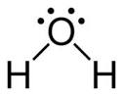

Steps for drawing Lewis structures: Example:

1. Count the valence electrons

2. Arrange the atoms. (symmetry if possible!)

3. Electrons on the outside atoms

4. Electrons on the inside atom

5. Check octet rule!

**Naming/Formulas Worksheet Name ____________________Per ___**

Basic Lewis Structure Practice 

**Basic Lewis Structure Practice**

|  |  |  |
| --- | --- | --- |
| Formula | Number of v.e. | Lewis structure |
| NCl3 | N=  Cl=  Cl=  Cl=  Total: |  |
| OF2 | Total: |  |
| XeBr2 | Total: |  |
| HCl | Total: |  |
| SiI4 | Total: |  |
| BF3 | Total: |  |

Challenging Lewis Structure Practice 

Example: CH2O

|  |  |  |
| --- | --- | --- |
| Formula | Number of v.e. | Lewis structure |
| SeS2 | Se=  S=  S=  Total: |  |
| CO2 | Total: |  |
| NCO | Total: | (C is the central atom) |
| SOCl2 | Total: | (S is the central atom) |

VSEPR Theory Notes 

VSEPR –

*There are 5 main shapes that molecules can take.*

## Shape 1:

|  |  |  |  |  |
| --- | --- | --- | --- | --- |
| Number of Electron Pairs around the central atom | Example | Drawing of the shape | Shape name | Bond Angle |
| 1 |  |  |  |  |
| 2 | http://4.bp.blogspot.com/_D2Wvf2DlD6o/TNny3xaPJoI/AAAAAAAAACc/fSxn1kB9JOk/s1600/carbon%252520dioxide.jpg |  |  |  |

## Shape 2:

|  |  |  |  |  |
| --- | --- | --- | --- | --- |
| Number of Electron Pairs around the central atom | Example | Drawing of the shape | Main shape name  *Specific shape name* | Bond Angle |
| 3 | http://www.vias.org/genchem/img/valel_bf3.png |  |  |  |
| 3 | http://ibchem.com/IB/ibfiles/bonding/bon_img/SO2.gif |  |  |  |

## Shape 3:

|  |  |  |  |  |
| --- | --- | --- | --- | --- |
| Number of Electron Pairs around the central atom | Example | Drawing of the shape | Main shape name  *Specific shape name* | Bond Angle |
| 4 | http://www.chemeddl.org/resources/models360/files/6393/cf4.png |  |  |  |
| 4 | http://www.uwplatt.edu/~sundin/images/lewnh3.gif |  |  |  |
| 4 | [http://ts2.mm.bing.net/th?id=H.4589513081487813&w=264&h=184&c=7&rs=1&pid=1.7](http://www.bing.com/images/search?q=water+lewis+structure&qpvt=water+lewis+structure&FORM=IGRE#view=detail&id=B17FB4883DA65F8AA6184A788B40D431BDD4FAC5&selectedIndex=0) |  |  |  |

Draw each molecule more accurately and identify its specific shape name.

|  |  |  |  |  |
| --- | --- | --- | --- | --- |
| Number of Electron Pairs around the central atom | Example | Drawing of the shape | Main shape name  *Specific shape name* | Bond Angle |
|  | http://edtech2.boisestate.edu/lindabennett1/images/NCl3%20Lewis%20Dot.jpeg |  |  |  |
|  | http://www.proprofs.com/quiz-school/upload/yuiupload/1240174075.jpg |  |  |  |
|  | http://www.chem.ufl.edu/~itl/2045/lectures/15_3fig.gif |  |  |  |
|  | http://www.chemeddl.org/resources/models360/files/6393/cf4.png |  |  |  |
|  | SeCl2 (Draw the Lewis structure!) |  |  |  |
|  | PH3 (Draw the Lewis Structure!) |  |  |  |
|  | H2S (Draw the Lewis Structure!) |  |  |  |

|  |  |  |  |  |
| --- | --- | --- | --- | --- |
| Number of Electron Pairs around the central atom | Example | Drawing of the shape | Main shape name  *Specific shape name* | Bond Angle |
|  | BH3 (Draw the Lewis structure!) |  |  |  |
|  | CCl4 (Draw the Lewis structure!) |  |  |  |
|  | AsH3 (Draw the Lewis structure!) |  |  |  |
|  | HI (Draw the Lewis structure!) |  |  |  |
|  | AlCl3 (Draw the Lewis structure!) |  |  |  |

Shape 4: Number of electron groups:

Drawing Bond Angles Name:

Shape 5: Number of electron groups:

Drawing Bond Angles Name:

Molecular Shapes Practice 

For each of these molecules:

* Draw the Lewis structure
* Draw a more accurate model of the molecule
* Predict the shape name and bond angle

|  |  |  |  |
| --- | --- | --- | --- |
| Molecule | Lewis Structure | Draw an accurate model | Predict the shape name and bond angles |
| NF3 |  |  |  |
| H2S |  |  |  |
| IBr4- |  |  |  |
| SeS2 |  |  |  |

|  |  |  |  |
| --- | --- | --- | --- |
| Molecule | Lewis Structure | Draw an accurate model | Predict the shape name and bond angles |
| BCl3 |  |  |  |
| OF2 |  |  |  |
| AsCl3 |  |  |  |
| XeF4 |  |  |  |
| KrBr2 |  |  |  |

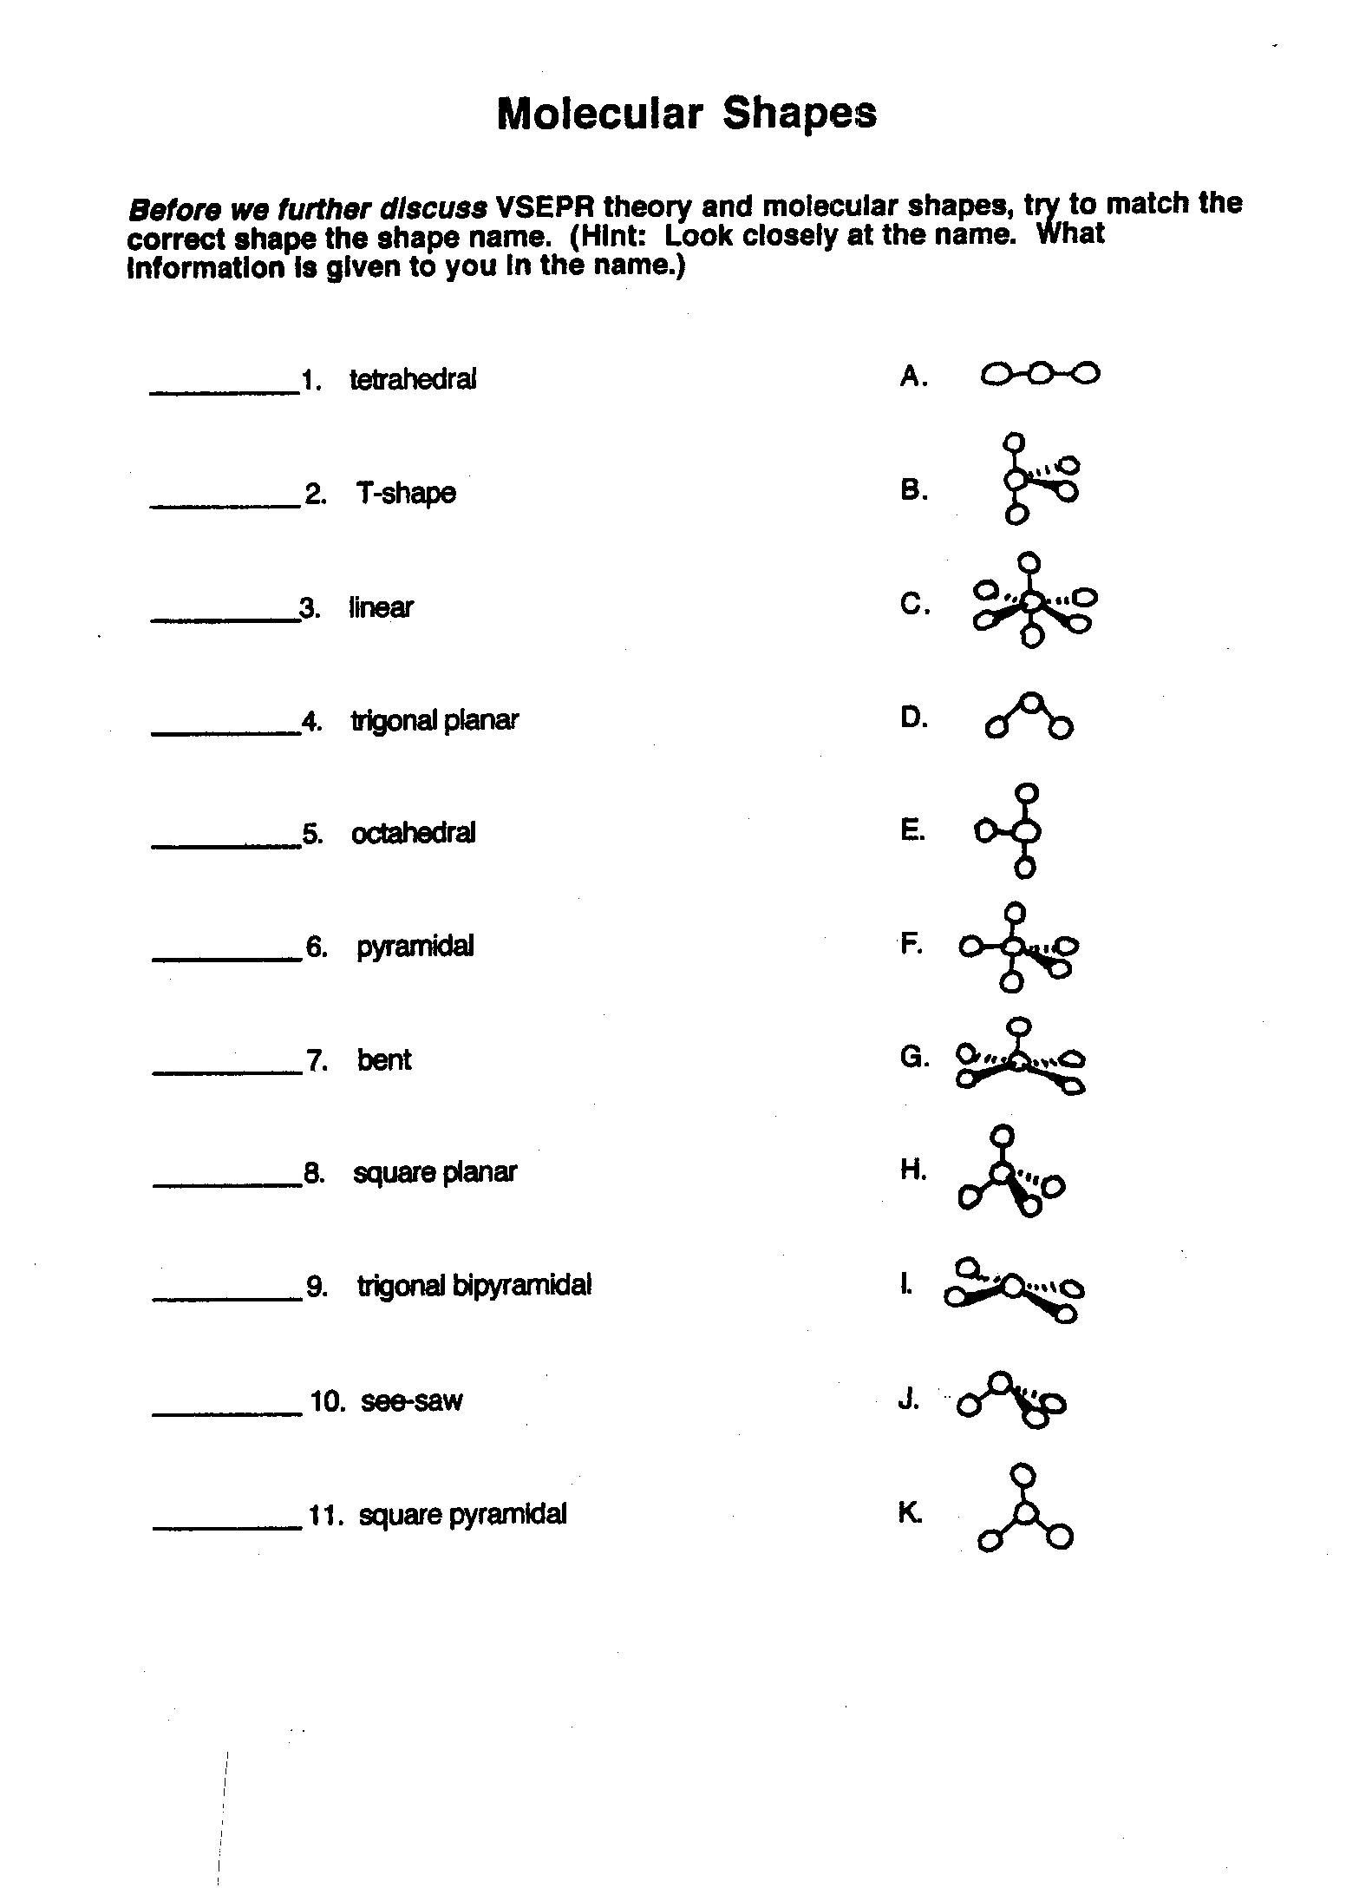

Polar Bonds Notes 

Define a polar bond:

What is the most polar kind of bond?

Define Non-polar Bond

Which of these are polar covalent bonds? (For those that are, draw the dipole)

Se-O P-P O-N Cl-Br O-O

Which of these polar covalent bonds would be the most polar?

C-N C-F C-O

