The Building and Challenges of Creating an Amphibious Vehicle from VCR and Printer Parts
Cassidy Steen, Ambriah LeRoux, Caylin La, and Rachel Himyak
2701 W. 136th Avenue Broomfield CO. 80020
Abstract
Our goal during this project was to engineer an amphibious vehicle using only parted from a dissected VCR player and a laser printer. To help build the vehicle, we were allowed three parts brought in from home; which consisted of a plastic tub (about 6.5“ by 5” by 2”), a motor taken from a hand held fan, and a nine volt battery to power the motors. While building the vehicle, we had many challenges, but our biggest challenge was getting the motor to spin the axle containing the wheel. This was a challenge because the motor was a gear motor, meaning that we had to use a gear with it. It was hard to keep the gears together to move, but after some creative brainstorming, we were able to make it work. In the end, the vehicle was able to travel ten meters, while traveling at a very slow pace, and was able to float and spin in circle in a tub of water. The determined criteria was met for this project.
Introduction
Our goal in this project was to make an amphibious car out of VCR and printer parts, as well as using three items brought from home, to accomplish having the car travel ten meters and float in water. Many projects have been attempted to make an amphibious car. Actually, there are real amphibious life scale cars that have been created. Amphibious cars aren’t a new idea. In fact, they’ve been around since the late 1800’s. The first amphibious car was created by Oliver Evans. The car was called “Orukter Amphibious.” This car used a steam engine. It was successful because it ran from Philadelphia around one mile; then it sailed in the Delaware River. Also, William Mazzei invented the second amphibious car in the middle 1910’s. This car used a continental machine; also called a hydromotor. The second amphibious car built had a speed of 60 mph on land, and 25 mph in water. Finally, the third amphibious car was named the Hydrocar. The third generation of amphibious cars was made by George Monnot. The Hydrocar was a combination between a truck, normal car, and a boat. This vehicle was used during war as a military vehicle.¹
As the year passed, the latest creation of an amphibious car is from the company, WaterCar. Dave March created the latest version of an amphibious car. A branch off the WaterCar is the Python. It exceeds 60 mph in water and a killer on the street. Python is the newest and latest generation of the amphibious car. The Python appears to be more like a sports car. Its top speed is 96km/h, and it is faster than a speedboat. The engine is based on the aluminum LS Corvette power train. This type of engine is able to produce energy of 640 horsepower. In order to conduct this vehicle in water, the gears have to be neutralized. Then, the steering of the jet and wheel needs to be powered on. In order to conduct this car on land, every operation is opposite by lowering the wheel and activate land steering. ²
There are various examples of social significance to this topic. Ever since the design went public, the amphibious car has many purposes such as search and rescues, expeditions, but mainly on the military. The amphibious car has been used mainly for warfare when W.W.II war began. Two of the most important amphibious cars were created during W.W.II. In 1942, the German Schwimmwagen was invented; it looked like a small 4x4 Jeep that was designed by Porsche. The second one was called the Amphi Ranger. Something interesting about this car was that it was sea water-resistant. This vehicle is important to the military because it helped out on beach landing operations, bring troops and cargo to shore. ³
The Hovercraft is the most commonly known amphibious car that’s mainly used by the military. It’s called an ACV also known as Air-Cushioned Landing Craft. The Hovercraft is supported by low-pressure air that’s released below the vehicle. It can work on anything smooth or rough.³

Design
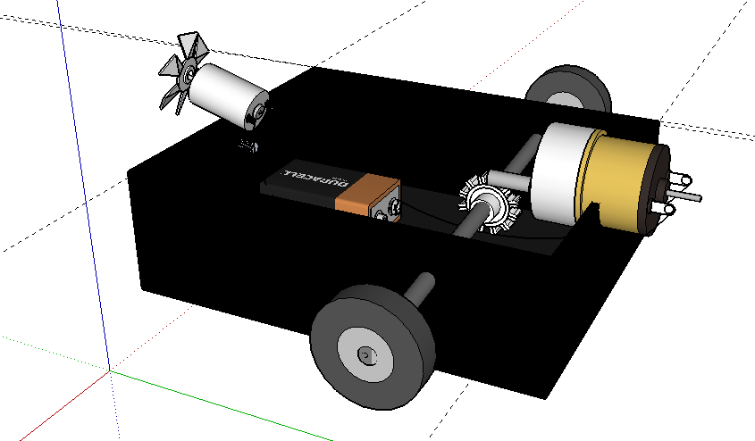
First, one plastic tub was used as the body of the amphibious car. Then, two holes were drilled on each side of the plastic tub and a metal rod, which was removed from the printer, was installed between the two holes. Two round objects that were taken from a printer and were used as wheels. The wheels were held onto the metal rod by hot glue and duct tape. Located on the middle of the metal rod was one small gear used from a VCR. The gear was then connected to a small gear motor by placing the motor on top of the gear so the spikes could intertwine with each other. The motor laid on top of the gear and was held in place by a long, rubber band that was removed from the VCR. The band was kept in place (on the other side of the plastic tub), by a screw. Four alligator wires were used in the car to connect the battery to both motors. The motors where never ran at the same time. Only one of the alligator wires were soldered on to a nine volt battery to make it quicker to connect the wires. Also, another printer wheel was used as a fan at the front of the amphibious car. Separate pieces of hard plastic were shaped into fans and hot glued on to the wheel to create a fan. The fan was then placed at the front of the car using tape and hot glue. Two alligator wires were attached to the motor of the fan and the battery to power the fan.
Figure 1: This is the design of the vehicle. *it is missing the rubber band due to difficulty with google sketchup*

Figure 2&3: This is the design of the vehicle. *it is missing the rubber band due to difficulty with google sketchup*

Results
Our criteria for this project was to build a vehicle that could travel 10 meters in no specific time limit. The vehicle was also to have the ability to float in water without sinking and have some movement in water. Based on this criteria, our vehicle was very successful, even if it did not move in a straight line or move very fast. It moved the full ten meters (and could have gone farther), floated in water, and “swam” in circles in water.
Discussion
Our project was an overall success, even though the vehicle moved very slowly. our final work came out to be to have only two wheels instead of the four which we had originally planned, they were located about halfway between the center of the plastic tub , and located more towards the back of the tub causing it to be rear wheel drive. The challenges created during our project took up the majority of the time we had to build the vehicle. Some of the problems we encountered, we weren’t even able to fix due to the time limits. For example, a few minor problems that we couldn’t change due to lack of more supplies and time consisted of the difficulty of drilling holes in the body of the vehicle for the axle to fit in and in the hole in the gear to fit onto the axle. The holes drilled in the sides of the tub that allowed the axle to go through the tub so the axle to fit through was not exactly strait and neither was the gear in the center of the car that the motor would turn. As a result the car did not drive strait and we could not fix this problem.
Other issues caused setbacks like trying to get the motor to stay connected to the gear on the axle. We finally fixed that problem by drilling another small hole in the front of the body of the car, placing a screw in it and looping a rubber band around the screw and motor to hold the motor in place. A major challenge was trying to get everything to work together with the limit of only three outside parts. We were forced to decide on what to bring in as extra parts. Because of this we had to build our own fan to propel the boat. When we had our final presentation, the boat spun in circles in the water.
If we were given more time to work on the vehicle, we would like to try and create a better fan that would actually propel enough air to get the vehicle moving faster and in a straight line. The fan we designed did not blow much air at all. It may be worth considering doubling the amount of power by using two batteries, instead of one, so more power to move the wind could pick up more. A rudder may need to be installed to accomplish going in a straight line. We would also like to try redoing the drilling for the axle to try and make it straighter to try and make it not turn.

References
1. "The Evolution of Amphibious Cars (Complete With Pictures)." prasetio30 on HubPages. N.p., n.d. Web. 9 Mar. 2012. <http://prasetio30.hubpages.com/hub/The-Evolution-of-Amphibious-Cars>.
2. "WaterCar - Builder of the World's Fastest Amphibious Car, Amphibious Cars, Amphibious Vehicles and Amphibious Cars." WaterCar - Builder of the World's Fastest Amphibious Car, Amphibious Cars, Amphibious Vehicles and Amphibious Cars. N.p., n.d. Web. 9 Mar. 2012. <http://www.watercar.com/>.
3. "Amphibious Cars." Rims, Used Rims, Used Wheels, OEM Wheels, OEM Rims available at OriginalWheels.com. N.p., n.d. Web. 9 Mar. 2012. <http://originalwheels.com/articles/amphibious-cars.php>.

