Descriptive Title That Hints at the Project Goal and Scale of the Project
Your Name, Your Name, and Your Name
2701 W. 136th Avenue Broomfield CO. 80020
Abstract
The abstract needs to include a short statement about the goals of the design, the major obstacles encountered, and the results of the project. The abstract should be one paragraph and generally less than 200 words. On an aside, let’s talk about the title. Be specific. “Designing a Car” is a bit misleading. “The Design of an Electric Motor Driven, Small Scale Vehicle From the Components of an Epson Printer” gives a much more accurate view of what is going on.
Introduction
This section is where you state the broad goals of the project. You also need to give context to your project. What previous or related designs have been done like this one before? Describe the scientific principles and engineering principles that apply to your project. When doing this, be sure to demonstrate the depth of your research. Demonstrate how that research is directly applied to your project. Just like in science research, watch out for disconnected projects. (Disconnected projects are those where lots of literature searching was done but very little of it was actually applied to the project). If you didn’t incorporate your gear research in your design, then don’t use it as the basis of your background research here.
Just like with science projects, you need to include figure labels using the format you see here. Bold that first part and include a descriptive statement of what is being shown. Reference the image.
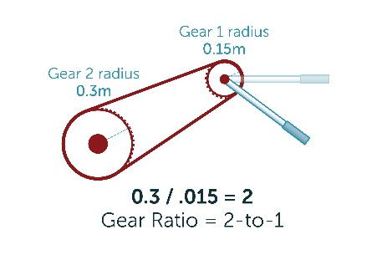

Figure 1. The relationship between radius of the driver gear and load gear was used to determine the change in torque that is delivered to the wheel.¹

If it is a math or physics project, you may need to include formulas using the formula editor in Microsoft Word. To find it, click “Insert”. On the far right side, you will see the “Equation” button. If you experiment, you will be able to make fairly complex formulas in a very neat way. For example, Figure 3 shows the relationship between centripetal force and linear velocity for an object undergoing circular motion.

$$F= \frac{mv^{2}}{r}$$
Figure 2. An equation showing the relationship between centripetal force and the velocity of the object.

Design
This is where you outline the initial design. There are 3 main ideas you need to outline here. 1. Specifically state the criteria for success of the project as they were initially established. THIS MUST BE VERY SPECIFIC AND NUMERICAL IN NATURE. Remember that the reader of this paper does not have any idea what you are doing so don’t miss the basics stuff like how large your vehicle was designed to be. (Is it a full size car? Usually not so be specific). How fast will it move in meters/second? How high are the undulations in the surface that it needs to cross? How much elevation will it need to gain? You should also have qualitative descriptors that are important. (Such as the texture of the surface.) 2. You must show at least one but preferably more figures of your design plan. These can be an overview as shown in Figure 3. They could show a magnified view of an important area as well. Then discuss the original design plan and why you chose this approach over others. 3. Show how the research from the previous section was applied to the project. If you applied gears, calculate the change in speed or torque you are expecting based on your available gears. There are lots of ways you could take this, so be creative and clever.

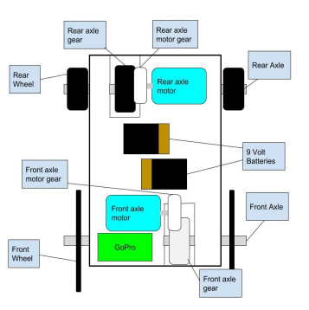

Figure 3. A top view of the original design showing the dual motor design plan.

Results
You will need a results section with measurements from when you tested the device. Yes, you need to measure how fast or how high your device went. A high level paper will apply a standard deviation to repeated trials just as with science papers. Decide if a graph would be helpful. (It is not necessary but helpful) Avoid doing any comparison of the results of your project to the original design until the next section, but if the method you used for the measurements was unique, then describe that here.

Maximum Height of Ball (cm)
175.2
175.4
175.1
173.4
173.6
173.2
Average (cm)
174.3 + 1.1
Discussion
Table 1. Data showing the affect of standing on a person’s height compared to their height while laying down.
Start the discussion by restating what your goals were and immediately give the main piece of data that shows how the project went. Discuss the challenges of the project. This does not include personal challenges and any narrative discussion that might be construed as a personal diary. For example, do not discuss lack of access to tools, or absent group members. These are real challenges that you may have faced but the goal of a technical report is to communicate DESIGN challenges that were confronted and ENGINEERED solutions to those challenges. If your ball did not experience enough friction from the metallic wheel that you used, how did you overcome that? A “sophisticated” project will include BOTH clever thinking and strong investigation of the literature for solutions to problems. Demonstrating that you overcame design challenges is the most important part of this paper.

References
Be sure to include references. These need to be in proper MLA format and demonstrate the solid foundation of research that your project is based upon.

